Electroencephalogram Signal Denoising in Individual Cognitive Ability Measurement using Independent Component Analysis

|  |  |  |
| --- | --- | --- |
| Tobias Mikha Sulistiyo *Master of Electrical Engineering Atmajaya Catholic University*  Jakarta, Indonesia  ORCID: 0009-0000-7587-750X |  |  |
|  |  |  |

***Abstract*— This study perfom a comprehensive investigation of individual cognitive abilities to assess the potential effects of drug exposure in teenagers. Electroencephalogram (EEG) signals, recordings of spontaneous electric fields generated by neuronal activity in the brain, played a crucial role in this research, enabling us to diagnose neurological conditions and explore applications in Brain-Computer Interface (BCI) technology. Nevertheless, raw EEG signals were prone to noise contamination, such as electromyography artifacts from muscle movements and electrooculography artifacts from eye blinking, which could adversely impact signal analysis. To overcome this challenge, we employed pre-processing techniques involving fourth-order Butterworth filters and Independent Component Analysis (ICA) to reject and reduce noise from the EEG data. The EEG signals were recorded while participants performed a go/no-go association task (GNAT), allowing us to gain insights into the cognitive responses and neural activity patterns related to drug exposure in the teenage population. The combination of EEG signal recording with the GNAT task provided a powerful and informative approach to understanding the cognitive implications of drug exposure in teenagers. In conclusion, obtaining a clean EEG signal is essential for accurately exploring the correlation between responses in the GNAT and brain waves, thereby enabling us to gain a deeper understanding of the cognitive effects of drug exposure in teenagers and its potential impact on neural activity patterns.**

***Keywords—EEG, GNAT, ICA, Noise Removal***

I. INTRODUCTION

The brain, being a vital organ, plays a crucial role as the central nervous system and in human memory. Comprised of a network of neurons, the brain exhibits coordinated electrical activity in response to stimuli, which is recorded as an Electroencephalogram (EEG) signal [1]. EEG signals offer valuable insights into a person's psychological condition and find applications in neuropsychology [2]. However, a significant challenge in EEG signal processing arises from the inherent noise contamination in the signals [3]. Noise, with varying frequencies and power levels, can disrupt the integrity of EEG signals and profoundly impact their processing and analysis [4]. Consequently, denoising techniques become essential during the pre-processing of EEG signals [5]. Given the diverse nature of noise in EEG signals, addressing this issue requires employing denoising techniques ranging from the simplest to the most complex separation methods.

Common types of EEG noise include muscle artifacts, ocular artifacts, electrocardiogram artifacts, line noise, and baseline artifacts. Among them, ocular and muscle artifacts are recognized as the most common sources of noise [6]. Numerous EEG noise rejection techniques have been proposed in previous studies. The simplest and computationally efficient methods involve using low-pass, high-pass, band-stop, or band-pass filters [7]. These filters effectively reduce line noise and muscle artifacts. Additionally, decomposition techniques like Hilbert Huang transform or empirical mode decomposition (EMD) are utilized to separate the EEG signal from noise, making them suitable for rejecting baselines or movement artifacts [8]. However, these approaches may not yield optimal noise reduction when the EEG signal is contaminated by multiple types of noise simultaneously.

To address this challenge, subsequent studies in EEG noise reduction or rejection have predominantly relied on the independent component analysis (ICA) method [9], [10]. ICA stands out for its ability to separate the EEG signal from noise without requiring a reference signal, a property known as blind source separation [11]. By employing ICA, a diverse range of noise can be identified and optimally reduced. Consequently, ICA has become a widely used method in general EEG analysis due to its exceptional performance in handling various types of EEG noise.

Considering these critical aspects, the denoising stage of EEG signals becomes a crucial concern for further signal processing. Thus, in this study, signal denoising was conducted on recordings obtained during cases of visual stimulation related to drug addiction. Throughout the recording process, respondents frequently exhibited body movements, eye blinks, and yawns, while line noise was also a common occurrence in the EEG signal recordings. To facilitate this research, a collaborative effort involving a team of psychologists from the Islamic University of Bandung (UNISBA) was undertaken, aimed at analyzing EEG signals concerning the terminology of addiction in adolescents. All respondents willingly participated in this study, having provided informed consent.

II. MATERIAL AND METHODS

*A. Electroecephalogram (EEG)*

Electroencephalography (EEG) is a technique employed to record the brain's spontaneous electrical activity by positioning electrodes on the scalp. Through EEG, voltage fluctuations resulting from the flow of ions within the brain's neural tissue are measured. Notably, EEG signals exhibit patterns associated with various emotional states, including excitement, exercise, and concentration [12].

During EEG signal recording, electrodes are affixed to the respondent, serving as conduits to capture neural signals. These electrodes are placed at specific locations, as depicted in Figure 1. To mitigate noise during the EEG recording process, an ultrasonic gel is applied to the electrodes, aiding in noise reduction. In EEG signal recording, a stimulus is commonly employed to elicit brain activity. This stimulus can take the form of sound, visual stimuli, or other triggers capable of inducing brain responses.

*B. Go/No-go Association Task (GNAT)*

The Go or No Go Association Task (GNAT) is a cognitive assessment technique utilized to measure an individual's cognitive ability. In GNAT's implementation, a response time limit is defined to evaluate how quickly individuals respond to the presented variables [4]. By imposing this time constraint, GNAT effectively assesses respondents' cognitive capacity to comprehend information, as they are required to respond within a brief timeframe. The specific time limit is determined based on the average human response time capability [13].

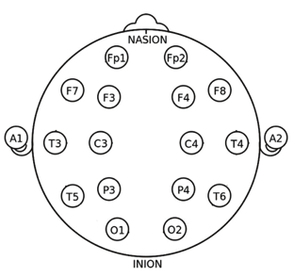

Fig. 1. The 16 channels EEG montage used in this study.

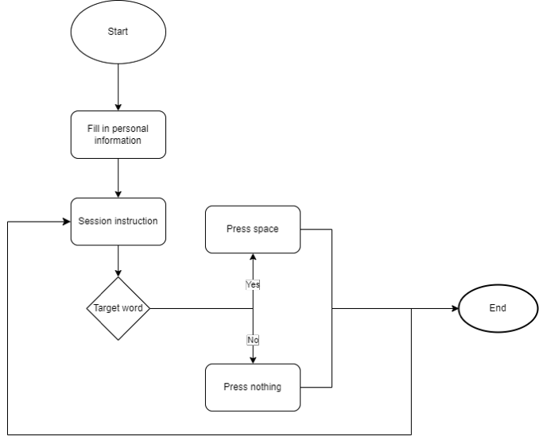

Fig. 2. GNAT system process

*C. EEG Signal Recording*

The EEG signal is recorded from 22 teenagers aged 16-18 years old using while performing GNAT.

*1) Stimulation using GNAT*

The EEG signal data is obtained using the Go/No Go Association Task (GNAT) as the stimulus. The recorded respondents consist of teenagers aged 16 to 18 years old. During the EEG signal recording process, the respondents are tasked with completing the GNAT test, and their EEG signals are simultaneously recorded. The processed signals primarily focus on capturing the respondent's condition while responding to the GNAT test based on the provided instructions. These conditions are further categorized into two groups: fast and slow responses. Fast responses refer to spontaneous answers or those provided within 0.5 seconds, while slow responses are those taking longer than 0.5 seconds to answer [13], [14].

Figure 2 illustrates the workflow of the system, depicting its operation. Respondents are instructed to select words that align with their understanding of addiction terminology. The respondents are categorized into two groups: normal and at- risk, based on their experiences with narcotics. Those in the normal category have no involvement or connection with narcotics, while at-risk respondents have personal experiences with narcotics or have friends or relatives who have used narcotics.

Figure 3 represents the initial page of the GNAT, which serves as the personal data entry page. Here, respondents fill in their name, age, and gender before proceeding to the session instruction page (Figure 4).

Figure 4 showcases an example of a session instruction page, providing target words for the specific session and explaining the GNAT procedure. Each session includes different target words. Once respondents understand the GNAT procedure, they proceed to the testing page.

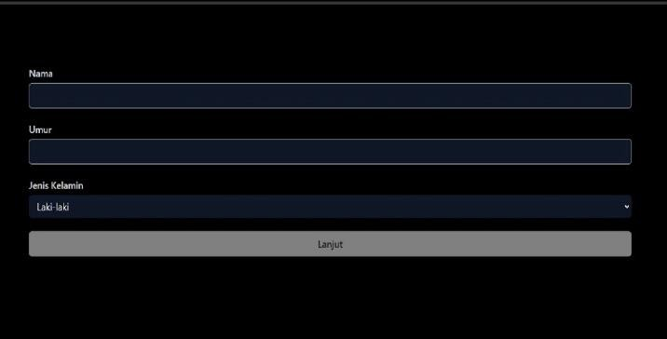

Fig. 3. Initial GNAT page (the interface uses *Bahasa Indonesia*)

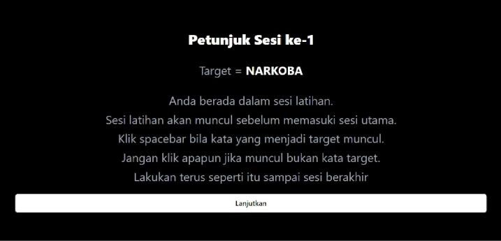

Fig. 4. Session instruction for participant (the interface uses *Bahasa*

*Indonesia*)



Fig. 5. Example of words that appear during the GNAT test, written in

*Bahasa Indoneisa*: “*Narkoba”* (Drug) and “*Berguna”* (useful)

Figure 5 represents an example of words that appear during the GNAT test. On the testing page, one word is displayed at a time, and the respondent is required to select the appropriate word. The order of words presented to each respondent is randomized. Each word remains visible for one second, and if the time elapses, the word automatically changes to the next prepared word. Within that time, the respondent must choose the word that aligns with the session instructions.

*2) Recording Setup*

Prior to commencing the EEG signal recording, participants are requested to fill an informed consent document, facilitated by the psychology faculty of Universitas Islam Bandung. Informed consent guarantees that participants possess comprehensive comprehension of the EEG recording's objectives and procedures. It outlines their voluntary engagement, data confidentiality assurances, and any potential risks or advantages associated with the study. By affixing their signature to the informed consent form, participants signify their readiness to partake in the EEG recording process.

The EEG signal recording takes place in Smart Data Sensing Laboratory, Telkom University. This room is selected for its soundproofing capabilities, which help reduce external noise that could potentially interfere with the EEG signal quality. The controlled acoustic environment of the lab ensures minimal disturbances, enhancing the accuracy of the EEG recordings.

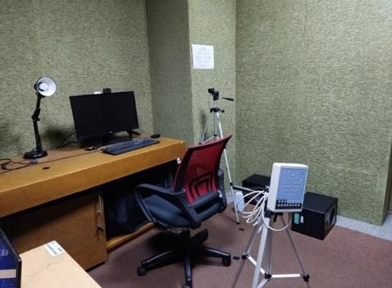

Fig. 6. The room setup used for EEG recording

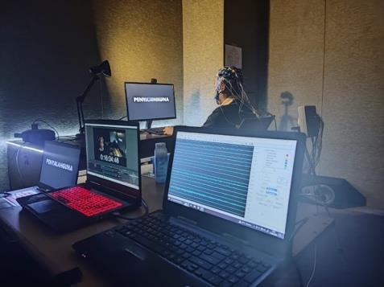

Fig. 7. EEG signal recording process

Figure 6 illustrates the placement of each device required for EEG signal recording. Each placement has specific distances, such as the distance between the respondent and the screen, which is set at 67 cm based on ergonomic considerations to ensure comfortable working conditions in front of the monitor [10]. A camera is positioned to capture both the keyboard and the respondent's face during the GNAT test. The camera recording the respondent's face is placed above the monitor, ensuring that the distance between the camera and the respondent is the same as the distance between the monitor and the respondent, which is 67 cm. Additionally, the camera capturing the keyboard is positioned to the right of the respondent and is placed at a distance of 53 cm from the desk. The recorded data of the respondent's performance during the test can be analyzed from a psychological perspective.

During the EEG signal recording process, the room setup shown in Figure 7 is utilized. The lighting in the room is adjusted to be dim, creating a conducive environment for the respondents to focus effectively during the test. Before starting the test, respondents are given the opportunity to adjust their positions for comfort. During the test, it is crucial to ensure there are no disturbances from external factors, such as noise or light. Providing respondents with a quiet and well- lit environment facilitates their concentration and focus during the test.

The camera serves as a medium to record the respondent's condition, providing a video output of the respondent during the test. The video recording includes timestamps that aid in time alignment when segmenting the EEG signal recording. These timestamps help accurately cut the EEG signal recording based on specific time points in the video recording. The timestamp and video recording are facilitated using the Open Broadcaster Software (OBS). OBS is prepared as the recording tool for the video during the test. The video recording starts when the respondent begins the first session, while simultaneously, the EEG signal is recorded using the EEG18 software.

The results of the EEG recording are analyzed technically, and the video recordings can be analyzed from a psychological perspective. Researchers can examine behavioral aspects, facial expressions, and non-verbal cues displayed by the respondents during the GNAT test. Additionally, the video recordings serve as a means to validate the EEG signal data and the results of the GNAT test. By comparing the recorded videos with the corresponding EEG signals and GNAT data, researchers can ensure the accuracy and reliability of the collected information.

*D. EEG Signal Filtering*

Filtering plays a pivotal role in EEG signal processing, involving the selective passage of specific frequencies while attenuating unwanted ones. The primary objective of filtering is to preserve the EEG signals that carry the desired information. In the context of EEG, informative signals typically operate within the frequency range of 4 to 40 Hz. The EEG signal comprises five distinct frequency bands: delta (0.4-4 Hz), theta (4-8 Hz), alpha (8-13 Hz), beta (13-30 Hz), and gamma (above 30 Hz) [12]. Each of these frequency bands represents unique patterns of neural activity and is associated with diverse cognitive and physiological states. Understanding and analyzing the characteristics of these frequency bands within the EEG signal offer valuable insights into brain functioning and mental states.

Filtering is a crucial step in EEG signal processing, and this study applied the 4th-order Butterworth filter which is a commonly used filtering technique for EEG signal. This filtering process is essential to extract and isolate the neural activity patterns represented by each frequency band, shedding light on various cognitive and physiological states. The 4th-order Butterworth filter's performance is highly valued in EEG signal processing due to its ability to achieve a balance between noise reduction and signal preservation. By accurately capturing and analyzing the characteristics of the EEG signals.

*E. Independent Component Analysis (ICA)*

ICA (Independent Component Analysis) is a widely employed method in signal processing, known for its capability to selectively choose or eliminate specific components [9]. As a statistical technique, ICA aims to disentangle a mixed signal into its independent components. In the context of EEG analysis, researchers commonly utilize ICA to identify and extract brain-related components of interest, or alternatively, to effectively remove unwanted artifacts or noise components from the EEG signal [10]. Through this process of component separation, ICA facilitates a deeper understanding of the underlying neural activity, ultimately leading to enhanced EEG data quality and improved insights into brain functioning.

III. RESULT AND DISCUSSION

*A. EEG Signal Recoring Result*

Figure 8 presents the results of the EEG signal recording, which reveals the presence of noise in the recorded EEG signal. This noise is attributed to the movements of the respondents during the GNAT test, where they are required to move their hands to complete the provided tasks. Such movements can introduce artifacts and noise into the recorded EEG signal.

The EEG signal recording shown in Figure 8 displays an irregular baseline pattern, further indicating the persistence of noise in the signal. This noise can be attributed to recording artifacts caused by body movements, as well as environmental conditions within the recording room.

*B. EEG Signal Pre-processing*

Preprocessing of EEG signals plays a critical role in reducing noise present in the EEG signal. Figure 9 illustrates the flowchart of signal preprocessing, which involves several essential steps, including the utilization of a filtering process. The filtering procedure allows only the signal's frequencies within a specific range to pass through. For this purpose, a fourth-order Butterworth filter is employed due to its linear phase response, which offers advantages over other filters [6], [7]. The cutoff frequency range chosen for filtering is 4 to 40

Hz, eliminating frequencies below 4 Hz as disruptive noise while retaining the relevant gamma frequency range up to 40

Hz [6]. This frequency range selection also aids in removing noise that may arise from external sources, such as power line interference, which typically occurs in the range of 50 to 60

Hz [6]. By applying this filtering process, the EEG signal is

effectively cleansed and prepared for further analysis and interpretation, emphasizing the relevant frequency

components while minimizing unwanted interference.

Figure 10 shows the EEG signal after filtering. The EEG signal after filtering exhibits a more improved baseline compared to before filtering. The signal represents the EEG

data obtained by passing the signal through a bandpass

Butterworth filter of fourth order with a range of 4 to 40 Hz.

Although the EEG signal after filtering exhibits promising results, it is important to acknowledge that some residual noise may still persist in the EEG signal. To evaluate the noise components within the channels, the Independent Component Analysis (ICA) method is employed. ICA has the capability to separate the independent components within the signal, enabling a more in-depth examination and analysis of the noise.

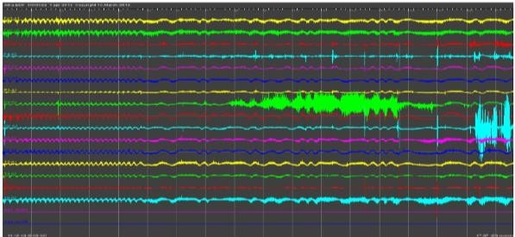

Fig. 8. The recorded EEG signals from 16 channels.

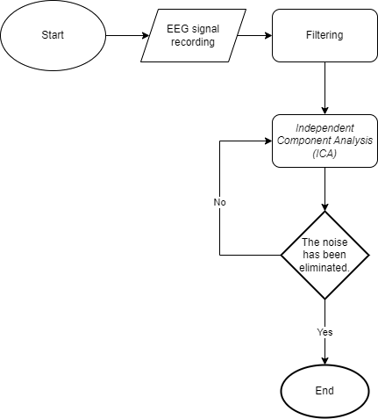

Fig. 9. EEG signal preprocessing process

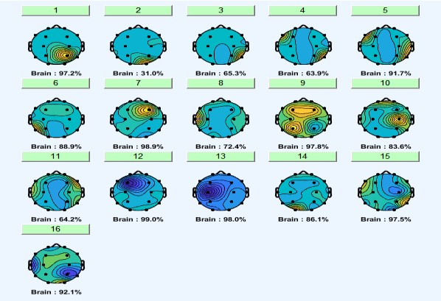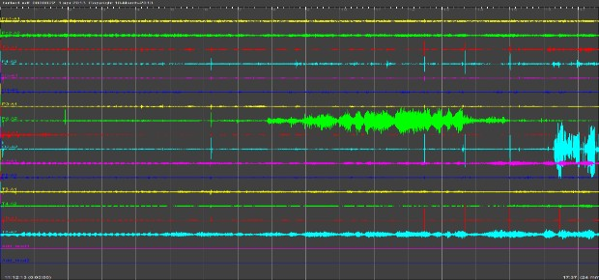

Fig. 10. EEG signals after filtering process

Fig. 11. Brain activity after filtering and removing unnecessary components

TABLE I. SAMPLE CALCULATION OF SNR, MAE, AND IMMSE

FROM 10 RESPONDENTS

|  |  |  |  |
| --- | --- | --- | --- |
| **Resp.** | **SNR** | **MAE** | **IMMSE** |
| 1 | 14.558 | 0.468 | 0.364 |
| 2 | 11.677 | 0.336 | 0.296 |
| 3 | 10.379 | 0.330 | 0.165 |
| 4 | 10.261 | 0.425 | 0.313 |
| 5 | 9.624 | 0.152 | 0.040 |
| 6 | 9.253 | 0.545 | 0.542 |
| 7 | 8.277 | 0.178 | 0.053 |
| 8 | 5.762 | 0.402 | 0.337 |
| 9 | 3.070 | 0.162 | 0.053 |
| 10 | 7.222 | 0.828 | 1.161 |
| **Avg.** | **9.008** | **0.383** | **0.332** |

Noise channels are observed in the filtered EEG signal, specifically in channels five and six. These noise channels can be attributed to the recording equipment utilized for EEG acquisition and potential interference from the recording device [8]. The ICA method is employed to determine the values of these components. With ICA, each EEG channel is analyzed to extract its corresponding components. Moreover, ICA possesses the capability to eliminate unwanted components from the channels, thereby further refining the signal. Figure 11 illustrates the EEG signal after applying ICA to remove components. Following the removal of these components with ICA, the brain activity in the EEG signal becomes more pronounced. Several channels exhibit changes in the energy component values. By eliminating the channel noise from the EEG signal, the detected signal in each channel accurately represents brain activity.

Table 1 showed the average of Signal-to-Noise Ratio (SNR), Mean Absolute Error (MAE), and Integrated Mean Squared Error (IMMSE) sample from 10 respondents EEG recording. A higher SNR value indicates that the denoised signals are significantly stronger compared to the background noise, highlighting the effectiveness of the denoising process. The low MAE value signifies that, on average, the denoised signals closely match the original signals, demonstrating the accuracy of the denoising method. Furthermore, the low IMMSE value indicates minimal distortion between the denoised and original signals across their entire lengths, firming the overall quality of the denoised outputs. These results validate the successful performance of the denoising experiment, suggesting that the denoised signals are well- preserved and highly reliable for subsequent analysis and interpretation.

IV. CONCLUSION

Brain signals, generated by the brain in response to various stimuli or cognitive processes, are crucial in understanding neural activity. During EEG signal recording, careful preparations are essential to minimize noise interference. Despite the best preparations, some level of noise may still be present in the signals. Therefore, effective EEG signal processing techniques, such as filtering and artifact removal, are necessary to reduce or eliminate noise components and obtain a cleaner representation of brain activity. Filtering

methods are selected based on the desired frequency range to pass through, but it is acknowledged that some noise may persist even after filtering. In such cases, the Independent Component Analysis (ICA) method proves valuable in further analyzing the components within each channel. Preprocessing the signal through these techniques sets the stage for extracting meaningful insights and information through subsequent analysis. By refining EEG signal quality, researchers gain a deeper understanding of neural responses and cognitive processes, advancing our comprehension of the brain's intricate workings.

REFERENCES

[1] A. Turnip, “Noise reduction and brain mapping based robust principal component analysis,” in 2015 IEEE 12th International Conference on Networking, Sensing and Control, 2015, pp. 550–553. doi:

10.1109/ICNSC.2015.7116096.

[2] K. Anjana, M. Ganesan, and R. Lavanya, “Emotional Classification of EEG Signal using Image Encoding and Deep Learning,” in Proceedings of 2021 IEEE 7th International Conference on Bio Signals, Images and Instrumentation, ICBSII 2021, Institute of Electrical and Electronics Engineers Inc., Mar. 2021, doi:

10.1109/ICBSII51839.2021.9445187.

[3] Y. Gaol, H. J. Lee, and R. M. Mehmood1, “Deep Learninig Of Eeg Signals For Emotion Recognition,” in 2015 IEEE International Conference on Multimedia & Expo Workshop (ICMEW), 2015, doi: doi:10.1109/icmew.2015.7169796.

[4] B. A. Nosek, M. R. Banaji, and B. Nosek, “The Go/No-Go Association

Task,” 2001, [Online]. Available: [www.briannosek.com](http://www.briannosek.com)

[5] Seel, N.M, “Encyclopedia of the Sciences of Learning,” in 2012

Springer US, 2012, doi: 10.1007/978-1-4419-1428-6.

[6] S. S. Daud and R. Sudirman, “Butterworth Bandpass and Stationary Wavelet Transform Filter Comparison for Electroencephalography Signal,” in 2015 6th International Conference on Intelligent Systems, Modelling and Simulation, 2015, pp. 123–126. doi:

10.1109/ISMS.2015.29.

[7] S. Kotte and J. R. K. Kumar Dabbakuti, “Methods for removal of artifacts from EEG signal: A review,” in Journal of Physics: Conference Series, IOP Publishing Ltd, Dec. 2020, doi: 10.1088/1742-

6596/1706/1/012093.

[8] A. Delorme and S. Makeig, “EEGLAB: an open source toolbox for analysis of single-trial EEG dynamics including independent component analysis,” 2004, [Online]. Available: <http://www.sccn.ucsd.edu/eeglab/>

[9] Albera, L., Kachenoura, A., Comon, P., Karfoul, A., Wendling, F., Senhadji, L., & Merlet, I, “ICA-based EEG denoising: A comparative analysis of fifteen methods,” 2012, *Bulletin of the Polish Academy of Sciences: Technical Sciences*.

[10] Rajaguru, H., & Prabhakar, S. K. Non linear ICA and logistic regression for classification of epilepsy from EEG signals, in *2017*

*International Conference of Electronics, Communication and Aerospace Technology (ICECA)*, *2017*-*Janua*, 577–580. https://doi.org/10.1109/ICECA.2017.8203602

[11] Yang, B., Duan, K., Fan, C., Hu, C., & Wang, J., Automatic ocular artifacts removal in EEG using deep learning, in 2018 *Biomedical Signal Processing and Control*, *43*, 148–158. https://doi.org/10.1016/j.bspc.2018.02.021

[12] Sanei, S., & Chambers, J. A. *EEG Signal Processing*, in 2007 John

Wiley & Sons Ltd,. https://doi.org/10.1002/9780470511923

[13] K. Anjana, M. Ganesan, and R. Lavanya, “Emotional Classification of EEG Signal using Image Encoding and Deep Learning,” in Proceedings of 2021 IEEE 7th International Conference on Bio Signals, Images and Instrumentation, ICBSII 2021, Institute of Electrical and Electronics Engineers Inc., Mar. 2021, doi:

10.1109/ICBSII51839.2021.9445187.

[14] M. Shahabi and A. Maghsoudi, “Prediction of drug response in major depressive disorder using ensemble of transfer learning with convolutional neural network based on EEG,” *Biocybern Biomed Eng*, vol. 41, Jun. 2021, doi: 10.1016/j.bbe.2021.06.006.